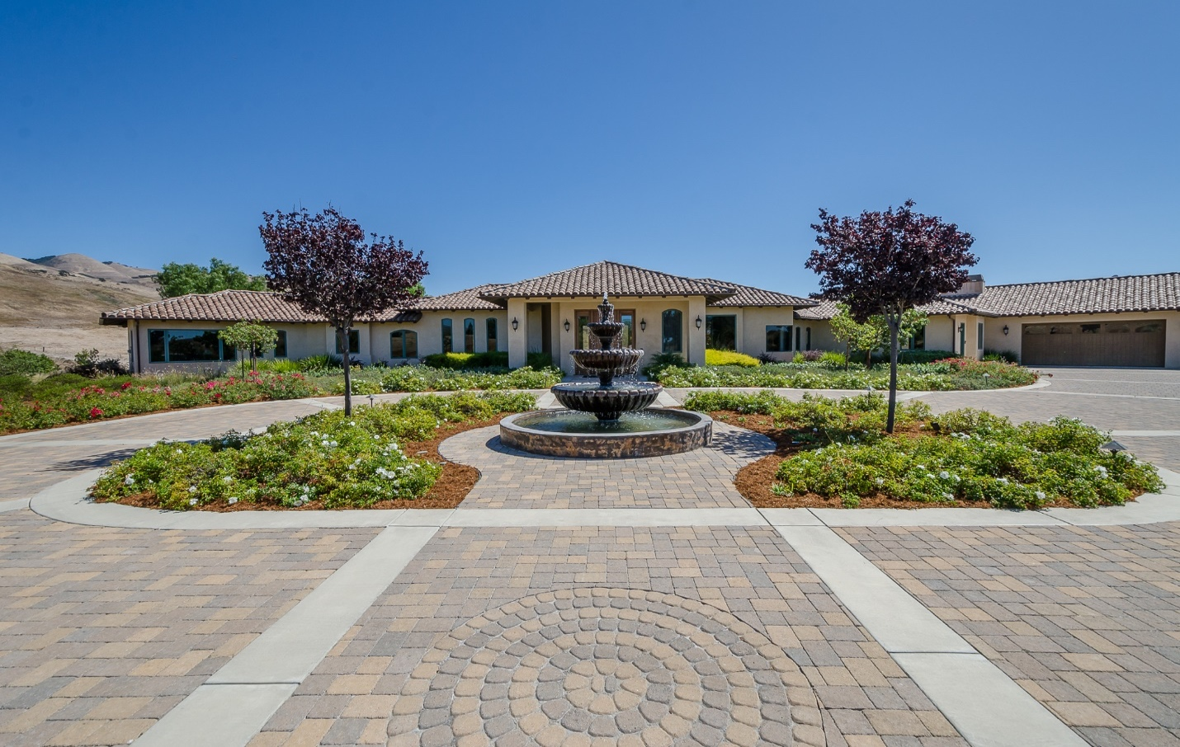*7120 Cerro Robles San Luis Obispo*

*GENERAL FEATURES*

* *Custom 9 ft. front door*
* *Vaulted Ceilings*
* *Tongue and Groove wood ceilings*
* *Pella Casement Windows*
* *Frameless Corner Windows*
* *Custom 10 ft. Sliding Glass Wall*
* *Travertine Floors*
* *Hardwood Floors*
* *Radiant Floor Heating*
* *Air Conditioning*
* *Photovoltaic Solar*
* *Solar Water Heater*
* *1.7 Acres*
* *Expansive paver driveway and patios*
* *3 Fireplaces*
* *Skylights*
* *2 Laundry Rooms*
* *Hand troweled interior wall finish*
* *Wine Room with Temperature Control*
* *Hunter Douglas Custom Silhouette Window Coverings*
* *4 Car Garage with built-ins*
* *Custom Alder Cabinetry*
* *Office*
* *Built in 2007*
* *Beautifully Landscaped*

*LIVING ROOM*

* *Wall of glass opens to the covered patio*
* *Fireplace*
* *Wood Vaulted Ceiling*
* *Open to the Dining Room*

*DINING ROOM*

* *Travertine Floor*
* *High Ceiling*
* *View to the hills*
* *Butler’s Pantry*
* *Wine Cellar*

*KITCHEN*

* *Custom Alder Cabinets*
* *European Hidden Hinges*
* *Granite Counters*
* *Walk-in Pantry*
* *Built-in Miele Coffee System*
* *Wine Refrigerator*
* *SubZero Refrigerator and Freezer*
* *Wolf Double Ovens and a Warming Drawer*
* *Wolf 6 burner Gas Cooktop with Griddle*
* *Bosch Dishwasher*
* *Trash Compactor*
* *Large Center Granite Island with secondary Sink*
* *Eating Area*
* *Opens to the outdoor BBQ*

*FAMILY ROOM*

* *Fireplace*
* *Picture Windows to the hillside views*
* *Projector with drop down screen*

*MASTER SUITE*

* *Double Door Entry*
* *Walls of Windows*
* *Fireplace, Sitting Area*
* *Window Seat*
* *Built-in Desk*
* *Built-in Bookcases*

*MASTER BATH*

* *Radiant Floor Heating*
* *Steam Shower*
* *Spa Jetted Tub*
* *Marble counters*
* *Dual Vanities*
* *Towel Warmer*

*SECONDARY BEDROOMS itchen*

* *Guest Suite No. 1*
* *Walk-in Closet*
* *Bath with Marble Counters*
* *Tub/Shower*
* *Travertine Floor*
* *Large picture Window overlooks the Roses and Fountain*
* *Guest Suite No. 2.*
* *Walk-in Closet*
* *Bath with Marble counter*
* *Tub/Shower*
* *Travertine Floor*

*OFFICE*

* *Custom Cabintry*
* *Wood Flooring*
* *Opens to a back patio*

*LAUNDRY ROOMS*

* *No. 1 adjacent to the garage and kitchen*
* *Large granite counter*
* *French door to the exterior*
* *No. 2*
* *Located in the bedroom wing*
* *Granite Counter*
* *Sink*
* *Built-in ironing board*
  + - * + *oom wingxterior and kitchen*