1525 WOLLACART STREET, REDONDO BEACH.
FLOOR PLAN
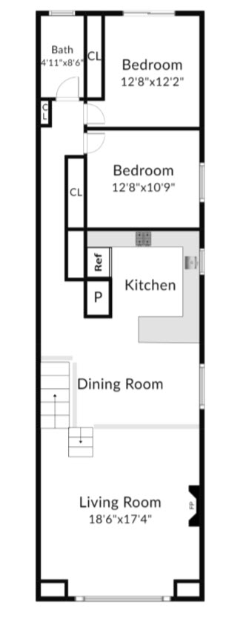
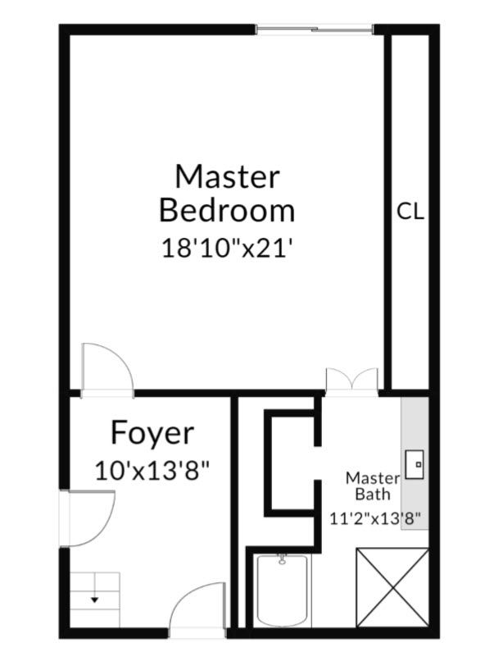

GROUND LEVELG GROUND LEVEL

UPPER LEVEL TOTAL SQ. FT. 1884 ( A )

