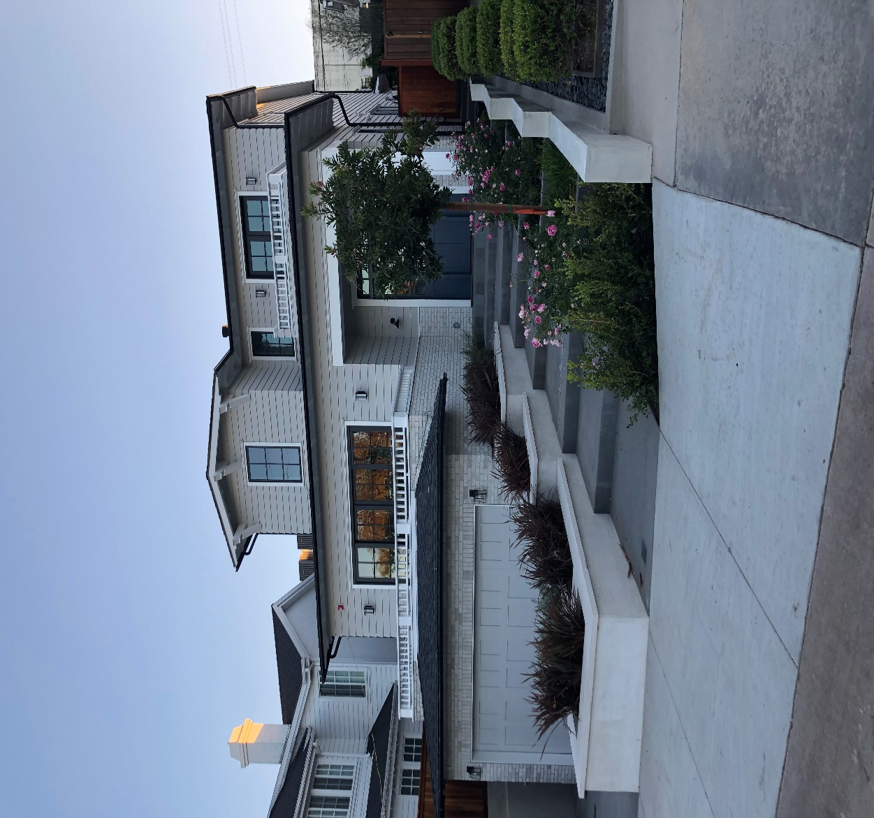

1716 Oak Avenue
  - Feature List


General Features
- Wide plank European Oak flooring
- Solid wood doors with glass knob hardware
- Emtek hardware throughout
- Designer Quality Delta Fixtures
- Designer lighting
- Separate heating and ventilation for first and second floor
- Prewired for whole home audio system
First Floor
Entry
- Blue-stone porch
- Vaulted clear cedar ceiling
- Dutch Door
- Coat closet
Great Room
- Linear fireplace with brick veneer
- Large folding door system
- Wood beam and T&G ceiling
- High deep shelf paneling
- Built-in vented cabinet

Dining Room
- Large formal dining room
- Wall paneling
- Butler pantry access
Kitchen
- Large custom color Island with seating
- Windows with direct view to backyard
- Thermador appliances
- Farmhouse apron sink
- Panel hidden refrigerator, freezer and dishwasher
Backyard
- Covered patio
- Custom firepit with mahogany top
- Large tree landscaping
- Mahogany wall cladding
- Built-in BBQ with refrigerator
Powder Bath
- Custom cabinetry
- Wall paneling
- Hinged mirror

Bedroom
- Extra large
- Private deck with 12-foot wide door
- Luxury bathroom
Basement
- Entertainment room
- Wall bar with wine refrigerator
- Full bathroom
- Wired for surround sound and projector systems
- Separate office area
- Oversized three-car garage
Second Floor
Stairway
- Solid oak stair treads
- Custom beam ceiling with T&G
Laundry
- Custom cabinetry
- Sink
- Concrete tile flooring

Bedroom One
- Double door closet with shelving
- Ceiling fan
- Jack and Jill bathroom
Bedroom Two
- Double door closet with shelving
- Ceiling fan
- Private patio
- Jack and Jill bathroom
Bedroom Three
- Vaulted ceiling
- Ceiling fan
- Double door closet
- Private bathroom
Master Bedroom
- Unique vaulted ceiling
- Ceiling fan
- Linear fireplace with brick cladding
- French doors leading to private deck
- Large closet with built in cabinetry

Master Bathroom
- Custom tile and marble
- Barn doors in entry and toilet area
- Oak cabinet double sink
- Built-in storage cabinets throughout
- Free-standing tub
- Vaulted ceiling with beams

