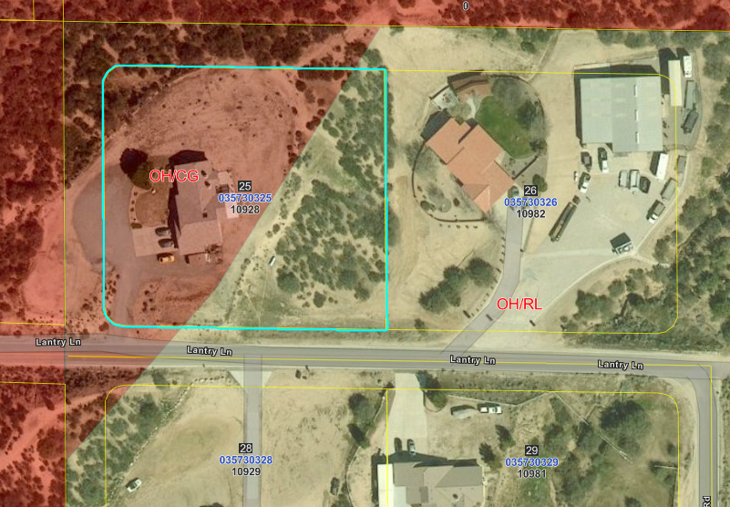
Dual zoning overlay:
Pinkish color is General Commercial zoning
Greenish color is Rural Living zoning
Contact County Of San Bernardino Planning Dept at
Andy Florimón
Junior Planner
Land Use Services Department
County Cell: 909-761-5975
385 N. Arrowhead Ave, 1st Floor
San Bernardino, CA 92415

