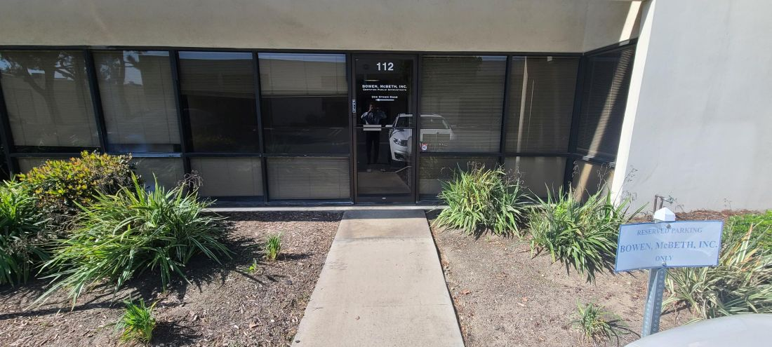
FEATURES
10722 Arrow Route, #112, Rancho Cucamonga, Ca.


- 3-Private offices.
- Office+Private 3/4 bath.
- 2-bathrooms.
- 24’x19’ Bonus room+storage room.
- 10’ x 12’ rear roll-up door.
- Lots of storage.

Asking Price $2805 mo.
FOR LEASE: 1728 SF Industrial-Office Flex building:
Ideally Located in the Heart of Rancho Cucamonga, close to RC Main Post office, restaurants, and court house.

This office space features:
10’ x 11’ Front waiting room; 3-private offices-one with private ¾ bath; Large rear 24’ x 19’ rear bonus room with 10’ x 12’ roll-up door; an additional storage room with cabinets, separate hall-way bath.
Tenant pays separate metered SCE; water & trash included.

Priced at: $2592 mo./ $1.50 SF
COMMERCIAL LEASE OPPORTUNITY

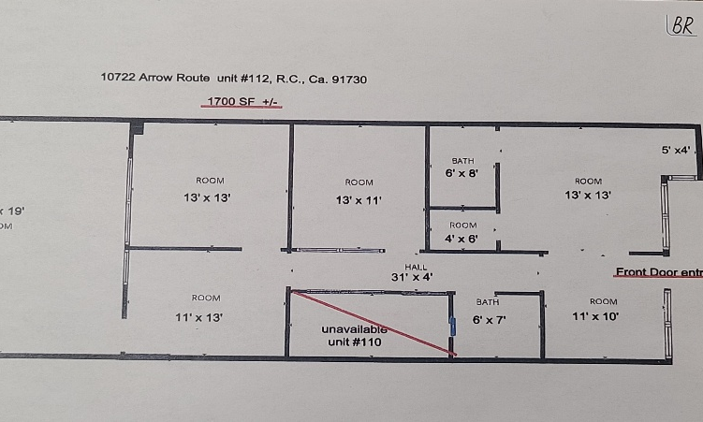
PRESENTED BY
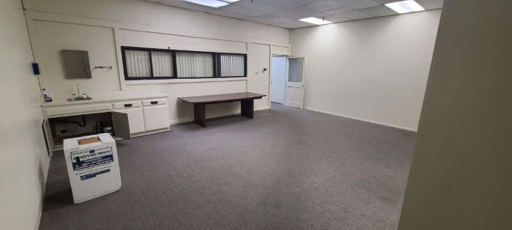
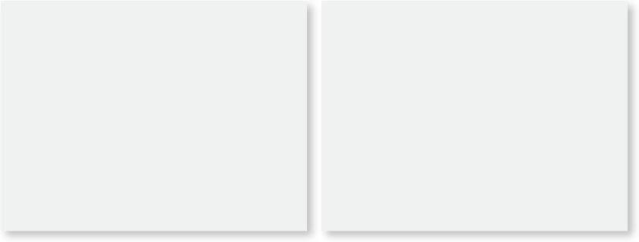
Bryan Rockwell
Commercial Associate
C#: 909-227-5757
DRE# 01250820
Brockwell@mgrrealestate.com
Jerry Tomeo
Sr. Commercial Associate
C# 909-996-8877
DRE# 01907707
Jtomeo@mgrrealestae.com

 | COMMERCIAL | RESIDENTIAL | PROPERTY MANAGEMENT  ONTARIO COSTA MESA VICTORVILLE RANCHO MIRAGE CARLSBAD IRVINE  (800) 777-7647 mgrrealestate.com DRE #01841921  All items on this page are deemed to be accurate, but should be viewed as reference only. MGR Real Estate, Inc. does not warranty/guaranty the validity of any information on this page.

