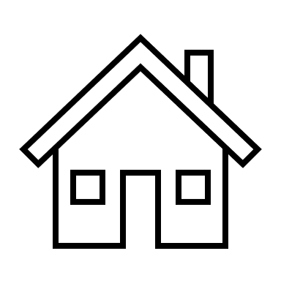

**List of Features**

**Exterior**

One of only a few two-story units

Covered front entrance

Rain gutters

Extra wide deck/patio with privacy (other units have open narrower/smaller decks or patios)

Private path from deck leading to side street

Direct garage access from garage to kitchen (a rare feature)

Large lighted storage room off garage

220V in garage

**Interior**

Kitchen stove area can be converted to gas

French doors from kitchen leading to deck/patio (others have small slider)

Newer vinyl dual pane slider from dining area to deck/patio

Newer vinyl dual pane windows in bedrooms

New scraped ceilings with added recessed lighting

New a/c ducting on first level

New ceiling fans in upstairs hallway and bedrooms

Cedar lined closets with organizers