MEMO

TO: Rich Gardner - Owner / Broker, Coastal Real Estate
Copies:
FROM: Charlie Cote

DATE: 22Sep2025

SUBJECT: 2249 Inyo St. Explanation of amenities and infrastructure

Contents
A. Floor plan 2
B. Rooftop solar panel generators 4
1. PV roof generator #1: installed in 2011 4
2. PV roof generator #2: installed in 2020 4
C. Flooring 4
D. Roof 4
E. Kitchen 5
F. Bathrooms 5
1. Master bath: 5
2. Main bath: 5
G. Loft 6
H. Fireplace 6
I. Furnace 6
J. Rainwater catchment 6
1. North side rainwater catchment 6
2. South side rainwater catchment 6
K. Washer and Dryer 7
L. Water heater 7
M. Hot water recirculation pump 8
N. Utilities 8

The descriptions and explanations in this document were requested by our Realtor, Rich Gardner of Coastal Real Estate.

Floor plan

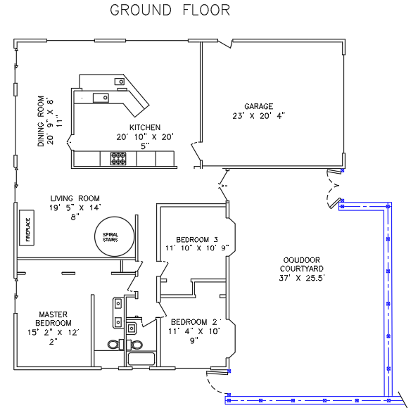
A spiral staircase in the living room leads to a 20 ft x 23 ft loft.

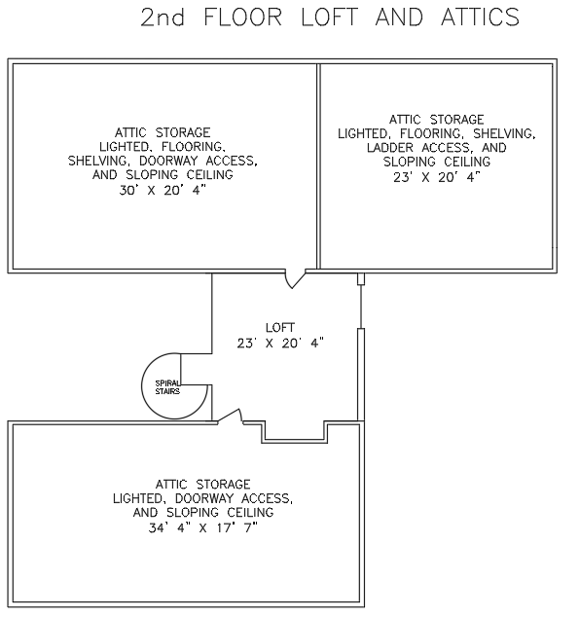

Rooftop solar panel generators
We have two rooftop photovoltaic (solar panel) generators on the roof. These systems were both installed by SunRun and continue to be maintained on a 30 year contract with that company. Both systems were installed on 30 year lease contracts, and the entirety of the lease payments have been prepaid. This means that the owner of the house has no monthly lease payments for these two solar power generators but will continue to enjoy the remainder of the 30 year maintenance agreements which were part of those lease agreements.

The current owners charge two electric vehicles from this system.

Electricity production information from both systems is available to the owner on the internet.

PV roof generator #1: installed in 2011
- 14 roof mounted solar panels with inverter and smart meter.
- 30-year pre-paid lease. No monthly lease payments and free maintenance by SunRun for duration of the lease period.
- 4,000 kWh generated during 2024
- Installed in 2011, Output guaranteed and free maintenance until 2041

PV roof generator #2: installed in 2020
- 10 roof mounted solar panels with inverter and smart meter.
- 30-year pre-paid lease. No monthly lease payments and free maintenance by SunRun for duration of the lease period.
- 4,500 kWh generated during 2024
- Installed in 2020, Output guaranteed and free maintenance until 2050

Flooring
New wood flooring was installed throughout the house in December of 2022.
MFG: Shaw Floors,
Style name: Landmark Sliced Hickory
Style #: SW748
Color name: Acadia
Color #: 01124

Roof
New roof (House & Garden Shed) by Bean Roofing July 2019 – 30 year composite shingles. 3 skylights were replaced/upgraded in 2019.

Kitchen
Two light tubes and two large skylights provide natural lighting.

Kitchen countertops are Emerald Pearl Granite slabs

Removable wood butcher block countertops on each side of range

Kitchen cabinets are Brookhaven Andover long grain maple with automatic door and drawer closure assist. Installed in 2009.

Gas range: Gourmet Professional 36” 6-burner natural gas cook top M/N GCG366SS installed in 2009.
Range hood: 36” Electrolux range hood with fan speed control and two overhead lighting modes.

Microwave: Whirlpool Model: WMC50522HZ, installed in 2022

Oven: Electrolux Model: EW30EW55GS4, installed in 2009.

Dishwasher: Maytag Model: MDB8959SKZ0, installed in 2022.

Refrigerator: Samsung Model: RF267ABRS, 26 cu ft., installed in 2009.

Bathrooms
Both bathrooms have SunTouch in-floor electric thermostatically controlled heating systems.

Master bath:
- Quartz countertop with two ceramic wash basins.
- Walk in shower with sitting bench.
- Low flow toilet
- Sun Touch in-floor thermostatically controlled radiant floor warmer.

Main bath:
- Single ceramic wash basin
- Low flow toilet
- Sun Touch in-floor thermostatically controlled radiant floor warmer.
- Jetted Bathtub

Loft
Spiral staircase in living room leads to a 23 ft x 20 ft loft area.
Skylight provides natural lighting. An adjustable screened window in the skylight provides adjustable air venting.
Doorways in the loft area provide access to attic storage area (refer to the floor plan).

Fireplace
Jackson XL Model 911XL, natural gas fireplace
RCT on/off thermostatic remote control system.

Furnace
Heating at this house is provided by a whole house ducted natural gas furnace. The natural gas furnace is in the garage attic. The furnace has been regularly serviced by the local installer since it was installed in 2009.

In 2019 the ducting was replaced/upgraded and new/upgraded insulation was added in the attic.

Furnace: Trane Model: TDE1B080A9451A, 80,000 BTU high efficiency downflow furnace.

Thermostat: RobertShaw Model 9610, digital programmable thermostat.

Rainwater catchment
The house has two rainwater storage collectors. A 500 gallon slimline tank is located on the north side of the house and hidden from view. Three 130 gallon slimline tanks are located on the south side of the house and hidden from view.

Water from the catchment tanks is used for watering the plants around the outside of the house. Water can be distributed from the tanks by using a long hose with a throttling valve at the end of the hose.

North side rainwater catchment
- 500 gallons of rainwater storage
- Sight glass on side of tank shows water level
- Horizontal roof catchment area of roof = 1,518 sq ft.
- 1/2 inch of rain produces ~ 463 gallons of water storage.
- Water filtering by a coarse debris screen in rain gutter, and a fine mesh screen at tank entrance.

South side rainwater catchment
- 390 gallons of rainwater storage
- Sight glass on side of each tank show water levels
- Horizontal catchment area of roof = 1,080 sq ft.
- 1/2 inch of rain produces ~ 329 gallons of water storage.
- Water filtering by a ‘first water’ separator in downspout system.

Periodic maintenance:
- Clean roof gutters at the beginning of the rainy season. Cleaning the gutters helps keep debris from clogging the coarse screens at the entry to the downspouts.
- Disinfect full rainwater tanks with a diluted bleach solution. This will keep algae from growing in the catchment tanks. The following methods will work for full water tanks:
  - Use 1/2 cup of unscented laundry bleach for 500 gallons of water.
  - Use 1/8 cup of unscented laundry bleach to treat the 130 gallon tanks.

Washer and Dryer
The washer and dryer were both new when installed in November of 2023.

GE electric washing machine.
M/N: GFW550SSN5WW
S/N: SV337727N

GE electric dryer
M/N: GFD55ESSN2WW
S/N: TV926366G

Water heater
The Rinnai gas fired on-demand water heater is installed on the north wall of the house beside the garage man-door. It was installed in 2009. We have hired a specialist HVAC contractor to do annual maintenance (heat exchanger flushing) on an annual basis and that contractor has not found any problems with that water heater. The flushed discharge water is clear and there has been no indication of scale depositing or corrosion.

Rinnai outdoor tankless water heater
Model: R75-LSe

Hot water recirculation pump
There is a hot water recirculation pump installed under the sink in the main bathroom. This recirculation pump is used for providing instant hot water to the bathroom showers and sink taps. Operation: Prior to needing hot water, the recirculation pump is started using the hardwired momentary button switch on the side of the main bathroom sink, or one of two remote control momentary switch that start the pump using radio control. After the recirculation pump starts it will pump water from the hot water pipe into the cold water pipe until a thermal switch automatically shuts the pump off. The pump typically only runs for 1 minute. After the recirculation has finished hot water will be immediately available at the showers and hot water taps.

ChiliPepper hot water recirculation Pump
Ref: https://chilipeppersales.com/
Dennis K Metzger
ChiliPepper Sales Inc.
1410 Greg St #408, Sparks, NV 89431
775-359-1223

Utilities
Water service: S&T Mutual Water Company
Website: https://st-water.com/
Rates: cost of water is based on a bimonthly (every 2-months) $130 meter charge plus water use charge based on the amount of water used during that 2-month period.

Electricity service: PG&E, via Central Coast Community Energy (3CE)
PG&E provides electric service and power grid connection for the two roof mounted solar panel systems. The monthly bills from PG&E include grid intertie and metering charges. An annual ‘True-Up’ bill charges for any incoming electricity used during that year can vary from $200 to $600. Note that the current owners charge 2 fully electric vehicles exclusively from their home charging system.

Natural Gas service: SoCal Gas
www.socalgas.com
Natural gas, used for the stove, furnace and fireplace, is provided by SoCalGas company.

Trash collection service:
Mission Country Disposal
A Waste Connections Company
4388 Old Santa Fe Rd
San Luis Obispo Ca 93401-8160
Billing every 2 months. ~$45.00/month
Owner separates waste materials into three provided cans; Green waste (compost), Recyclables, and Trash (landfill).

Contact information for Rich Garder, Owner / Broker, Coastal Real Estate Cell: (805) 440-8491, Email: coastal.realestate323@gmail.com

