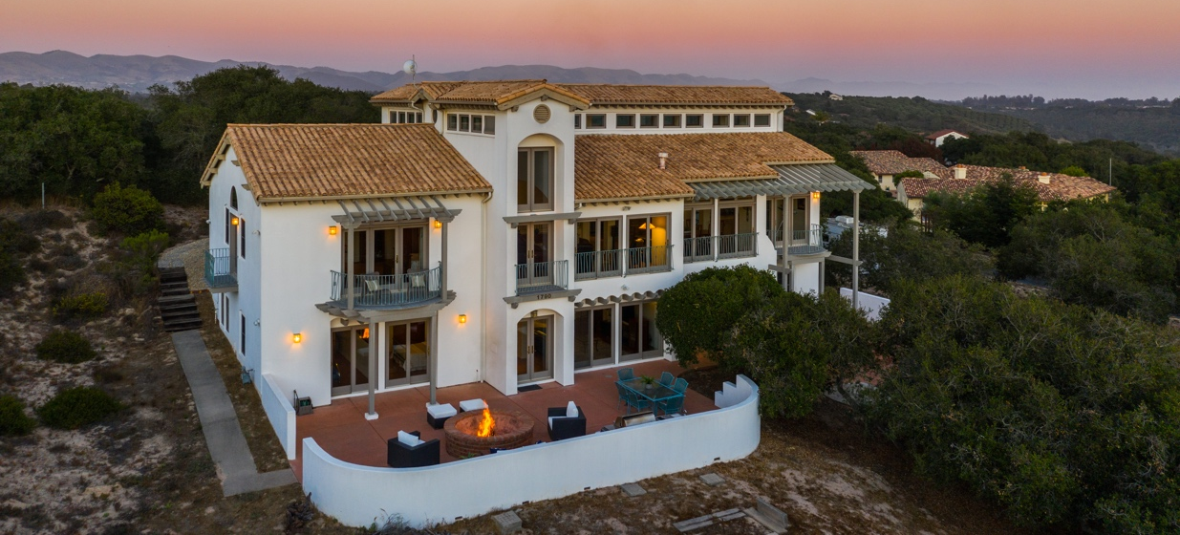

Custom Spanish-Style Home with Panoramic Ocean Views
1790 Calle Laguna, Arroyo Grande

.
Perched atop the Arroyo Grande Mesa within the private gated community of Black Lake Estates sits 1790 Calle Laguna, an authentic Spanish style, custom built 5 bedroom, 4 bathroom home on just under 3 acres. From almost every room of its 4,598 square feet one can enjoy breathtaking panoramic views of oak studded rolling hills, the Pismo dunes and the Pacific Ocean. The clerestory ceilings, oversized windows and sweeping archways give the grand rooms a light, airy feel, while natural wood beams, Saltillo tile flooring and cherry wood finishes provide warmth. Ideally located just minutes from the Village of Arroyo Grande, Pismo Beach, and San Luis Obispo, yet remote enough to feel like a private getaway, this is truly a jewel of the Central Coast.

On the property’s main floor one can enjoy a spacious living room, dining room, kitchen, powder bath, master en suite and multiple balconies to enjoy the exquisite views. The centrally located kitchen is a fabulous setting to entertain your family and friends, featuring granite countertops, cherry cabinets, stainless steel Viking® and Kitchen Aid® appliances, a wine rack and large center island. The generously sized master en suite boasts vaulted ceilings, two private balconies, and a large bathroom with walk in closet and jetted tub. The lower level of the home includes a media room complete with surround sound, a wet bar with mini fridge and wine fridge, four bedrooms, two bathrooms, a sauna, and a bonus room that is currently being used as a gym. The lower level provides access to the back patio, complete with a full outdoor kitchen, an oversized fire pit constructed with handmade Mexican bricks, and a horseshoe pit. An adjacent patio sets the scene for the ultimate private retreat, with a concrete pad ready for your hot tub.

The property is located just 10 minutes from the Village of Arroyo Grande, 15 minutes from Pismo Beach and 25 minutes from San Luis Obispo. The 3-car garage, RV parking and additional storage space provide plenty of room for all of your toys. With nearly three sprawling acres of mature oak trees and natural landscaping the possibilities are endless to create your ultimate dream retreat.
.
1790CalleLaguna.com

Overall

- Approx. 4,598 sf*  - Approx. 2.75 acre lot (per tax records)  - Custom built in 1999 by architect Gustav Joslin  - 5 bedrooms, 4 baths, office & bonus room  - Located in the Black Lake Ranch Estates on the Arroyo Grande Mesa  - HOA $880 annually  - Panoramic ocean and hillside views  Surrounded by 15-20 acres of common area maintained by HOA  - Multiple decks off living area and master suite with exceptional views  - Washable, silastic exterior paint and iron railings to withstand coastal climate  - Master suite on main level  - Marvin® doors and windows with cherry interior and metal clad exterior  - Gas fireplace in great room  - Clerestory ceilings in great room with motorized windows and reversible ceiling fans to naturally control temperature  - Forced air heating  - Exposed wood beamed ceilings in great room  - Hand painted murals by local artist Heather Roy in entryway  - Granite & Corian counters throughout  - Saltillo tile throughout with laminate flooring downstairs  - Cherry cabinets, doors and trims  - Solid brass hardware  - Ample storage space in house with attached 9x12ft storage area accessible from exterior | - Viking® and Kitchen Aid® stainless steel appliance  - Gas and electric hook-up in laundry room  - 3-car garage with built-in cabinetry and (unpermitted) sound proofed music room  - Private well  - Natural gas  - Conventional Septic  - Lutron® lighting system with remote phone access  - Light fixtures by American Art®, Barkeley® and Mission®  - Optex® security system with secure window screens and mobile alerts  - Fire sprinkler system & wired smoke alarms  - High speed, wide band WiFi provided by Digital Putty®  - Built-in speaker system with surround sound in downstairs entertainment room  - Authentic Mexican Redland Clay Tile Roof  - Full outdoor kitchen with stainless steel BBQ, range, and wet bar  - Extra Large Fire Pit constructed with handmade bricks from Mexico  - Horse shoe pit  - RV parking  - Indoor Sauna by Nordic®  - Full wet bar with built in wine fridge and mini fridge  - Jacuzzi pad privately situated among the oak trees
.

MAIN FLOOR
Foyer
- Grand entrance with abundance of oversized, Cherry wood and glass doors  - Views of the ocean and hills upon entry  - Elegant archways and columns with smooth finish  - Hand painted murals by local artist Heather Roy | - Expansive clear story ceilings  - Motorized windows and reversible ceiling fans to naturally control temperature  - Natural exposed wood beams  - Saltillo tile flooring
Kitchen
- Cherry wood cabinetry  - 1 inch solid granite counters  - Saltillo tile flooring  - Views of ocean and hills  - Open to dining room and living space  - Large center island with breakfast bar  - Wine storage rack | - Stainless steel sink  - Stainless steel appliances (included):  - Viking® 6 Burner Gas Stove  - Viking® Oven (Electric)  - Panasonic® Microwave  - Kitchen Aid® Refrigerator  - Kenmore® Dishwasher
Dining Room
- Expansive picture windows with panoramic ocean and hill views  - Saltillo tile flooring  - Metal Chandelier by Berkeley® | - Room for an extra-large dining table to seat 10+ people
.
Great Room
- Spacious & bright room with panoramic views of the ocean and hills  - High ceilings with sweeping archways  - Saltillo tile flooring  - Wired in sound system  - Open concept | - Gas fireplace  - Multiple private decks (Trex®)  - Guest bar seating with additional storage overlooking views of the ocean  - Cherry cabinetry
.
.

Powder Bathroom
- Located off entryway
- Saltillo tile flooring
- Pedestal Sink

Main Floor Master En Suite
- Main room:  - Vaulted ceilings  - Large picture windows  - Two private balconies overlooking ocean, hills & oak trees  - Saltillo tile flooring  - Walk-in closet  - Custom Drapes and hardware | - Master Bath:  - Oversized Kohler® jetted tub  - Walk-in marble shower with glass block enclosure  - Marble counters with double sinks and vanity area  - Private toilette room
. ..

Laundry Room
- Located off kitchen  - Cherry wood cabinetry  - Sink | - LG® Washer & Maytag® Dryer  - Gas and electric hook-ups  - Saltillo tile flooring
.

Downstairs

Central Stairwell
- Saltillo tile flooring  - Iron railing  - Split staircase leading to entertainment room | - Metal Chandelier by American Art®
.
Entertainment Room
- Sweeping archways and columns  - Access to back patio through sliding glass doors  - Wired-in surround sound | - Laminate flooring  - Full wet bar with two bar stools  - Built in mini fridge and wine fridge  - Black-out window coverings

.Bedroom 2, 3, 4 & 5
- Picture windows with views of the oak trees  - Laminate flooring | - Ample closet space  - Custom window treatments
.

Guest Bathrooms
- Cherry wood cabinetry  - Corian counters  - Natural wood plank sauna | - Saltillo tile flooring  - Walk-in Shower and Shower/Tub
.

Bonus Room/Gym
- Direct access to back patio through sliding doors
- Carpet flooring
- Large mirror covering wall
.
EXTERIOR
Grounds
- Panoramic ocean and hillside views  - Large driveway with ample parking space  - RV parking  - Saltillo tile and concrete patios  - Fountain  - Outdoor kitchen complete with stainless steel BBQ, range and wet bar  - Wired-in sound system  - Private Well  - Conventional Septic | - High speed, wide band WiFi provided by Digital Putty®  - Extra-large firepit constructed with handmade bricks from Mexico  - Low maintenance landscaping with mature oak trees  - Large storage area with garage door enclosure  - Concrete pad situated in private area among oak trees suitable for a hot tub
.
Garage
- 3-Car Garage  - Built-in Shelving  - Water Heater  - Bradford White®  - Installed 11/29/2016  - 75-gallon | - Music room (unpermitted) created for the ultimate listening experience  - Skylight  - Sound-proofed walls
*All information provided by seller. Information deemed reliable but not guaranteed. Seller to verify independently. Seller to provide list of exclusions.
.
Represented by Abigail Maguire & Brad Wilson
Wilson & Co. Sotheby’s International Realty
c 805.458.3230 o 805.543.7727 c 805.550-2113
Abigail.Maguire@sothebysrealty.com Brad.Wilson@sothebysrealty.com
3590 Broad Street, Suite 130, San Luis Obispo, CA 93401
REALTOR® CalBRE #02023157 REALTOR® CalBRE #01983603

WilsonandCoSIR.com
.
This offering is subject to errors, omissions, changes, including price, or withdrawal without notice. ®,TM and SM are licensed trademarks to Sotheby’s International Realty Affiliates, Inc. An Equal Opportunity Company. Equal Housing Opportunity. Each Office is Independently Owned and Operated, Except Offices Owned And Operated By NRT Incorporated.

