****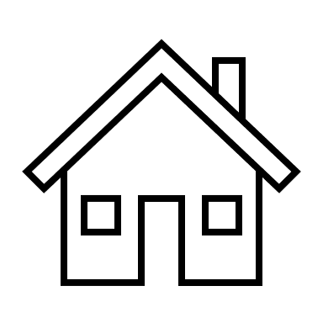

Property Upgrades – 2114 2nd Ave

**Total Spent: $42,778**

* Autonomous Work Pod $20,905
* New Roof 2021 $7,550
* New Sliding Doors from “The Sliding Door Company” $5,368
* Washer and Dryer Install 2021 $1,765
* New Exterior Paint 2024 $3,000
* Recessed Lighting, Pottery Barn Shelving, Fresh Interior Paint: $3,000
* New side yard fence and staircase: $1,200