

La Playa #1602

Offer Instructions

Thank you for your interest in 1710 Avenida Del Mundo #1602. To help you submit the strongest offer, please see the details below:

- Seller Name: Albert & Regina Kovach Family Trust

- Coronado Shores Company – License Number: 00658736

- Felicia F. Bell - License Number: 00429681
Stacy Bell Begin – License Number: 02014995

- APN: 537-695-02-56

- Deposit to be 3% of purchase price.

- Escrow: Crown City Escrow

- Title: First American, Greg Ives

If you have any questions, please contact Felicia or Stacy.

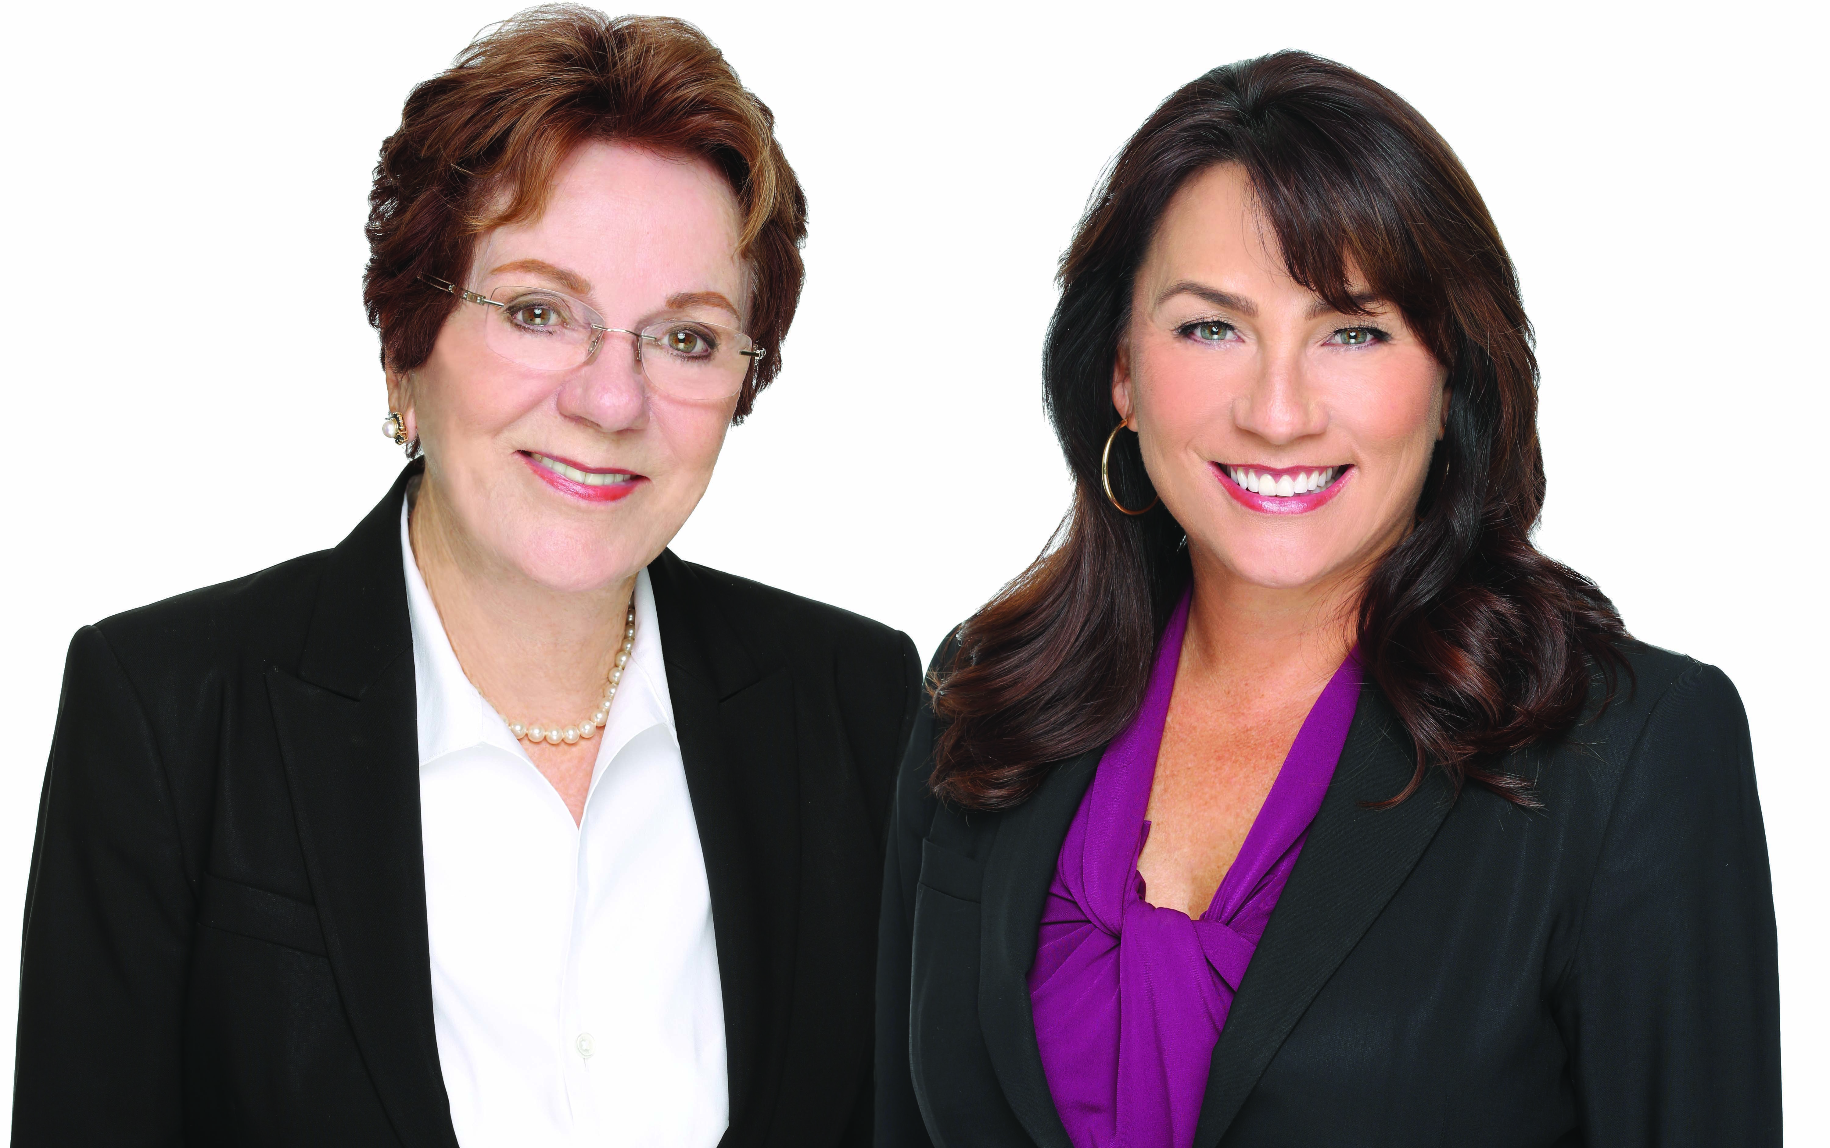

Felicia F. Bell Stacy Bell Begin
Associate Broker, GRI Realtor
DRE License #00429681 DRE License #02014995
619-920-9124 619-200-9184

