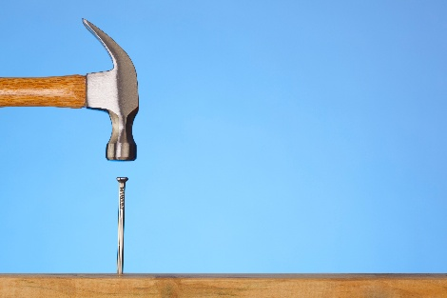

1703 La Play Ave, Unit B- Seller Upgrades:

- New flooring/LVP throughout the unit
- New cabinets in kitchen, bathrooms and laundry room. Real wood shaker cabinets and real wood interiors/boxes (plywood with dovetail drawers).
- New quartz counter tops in kitchen and bathrooms.
- New stainless-steel appliances , new stainless-steel sink and faucets, new garbage disposal, new bar sink and faucet.
- In all bathrooms (including master bath) new sinks and faucets, new toilets, new LED lighting, new vanity mirrors, new bathroom accessories, new tub (jack and jill bathroom) including new shower and faucet.
- New LED light fixtures throughout the unit, including 5 exterior balcony lights, new switches, dimmers and receptacles throughout, new thermostat, new ceiling fan (dining room).
- New door handles throughout.
- New paint, walls and ceilings throughout.

