RETAIL SPACE AVAILABLE FOR LEASE
823 GRAND AVENUE
SAN MARCOS, CA
FREEWAY VISIBLE PROPERTY NEAR SAN MARCOS BLVD.
140,000 ADT ON 78 AND 11,382 ADT ON GRAND
EASILY ACCESSIBLE
NEAR CAL STATE SAN MARCOS AND PALOMAR COLLEGE
NEAR CREEKSIDE DEVELOPMENT, COSTCO AND OTHER RETAIL STORES
WITHIN 3 MILE RADIUS HOUSEHOLD INCOME IS $78,788 AND POPULATION IS 96,442
RETAIL/OFFICE SPACE AVAILABLE: 2,112 SQUARE FEET.
LEASE RATE: $1.40 PER SQUARE FOOT PER MONTH NNN WITH ANNUAL INCREASES.
ESTIMATED NNN CHARGES: $.73 PER SQUARE FOOT PER MONTH WITH ANNUAL ADJUSTMENT TO ACTUALS
AMPLE PARKING AT 5.4 SPACES PER 1,000 SQUARE FEET OF BUILDING AREA
CONTACT LU ANN HALL AT (760) 505-8902
DRE#007 19299

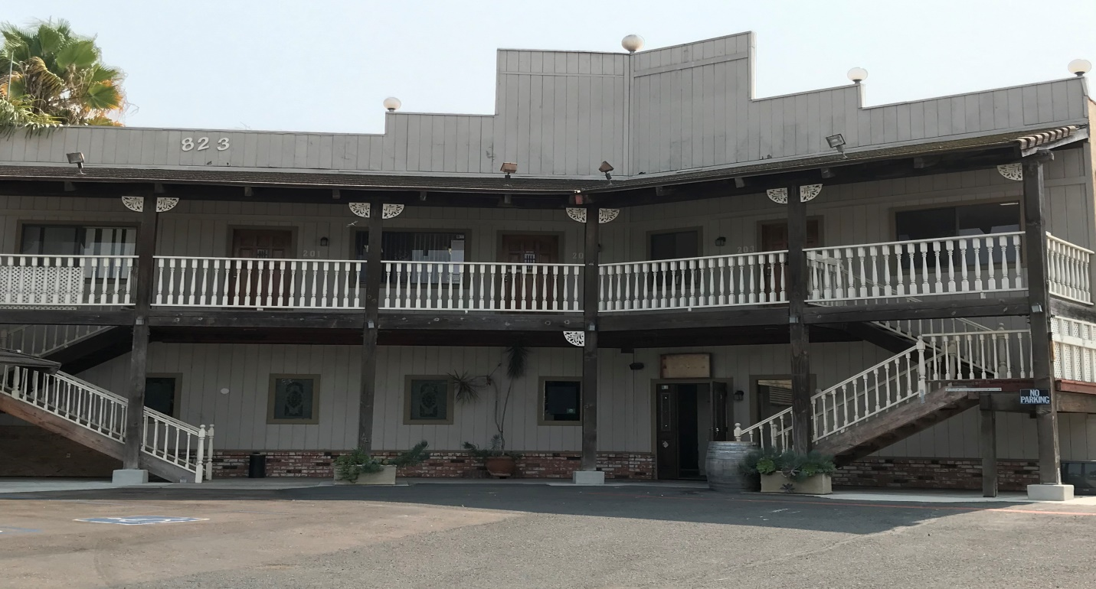
823 GRAND AVENUE

