1141 CERRO LARGO DRIVE
SOLANA BEACH, CALIFORNIA
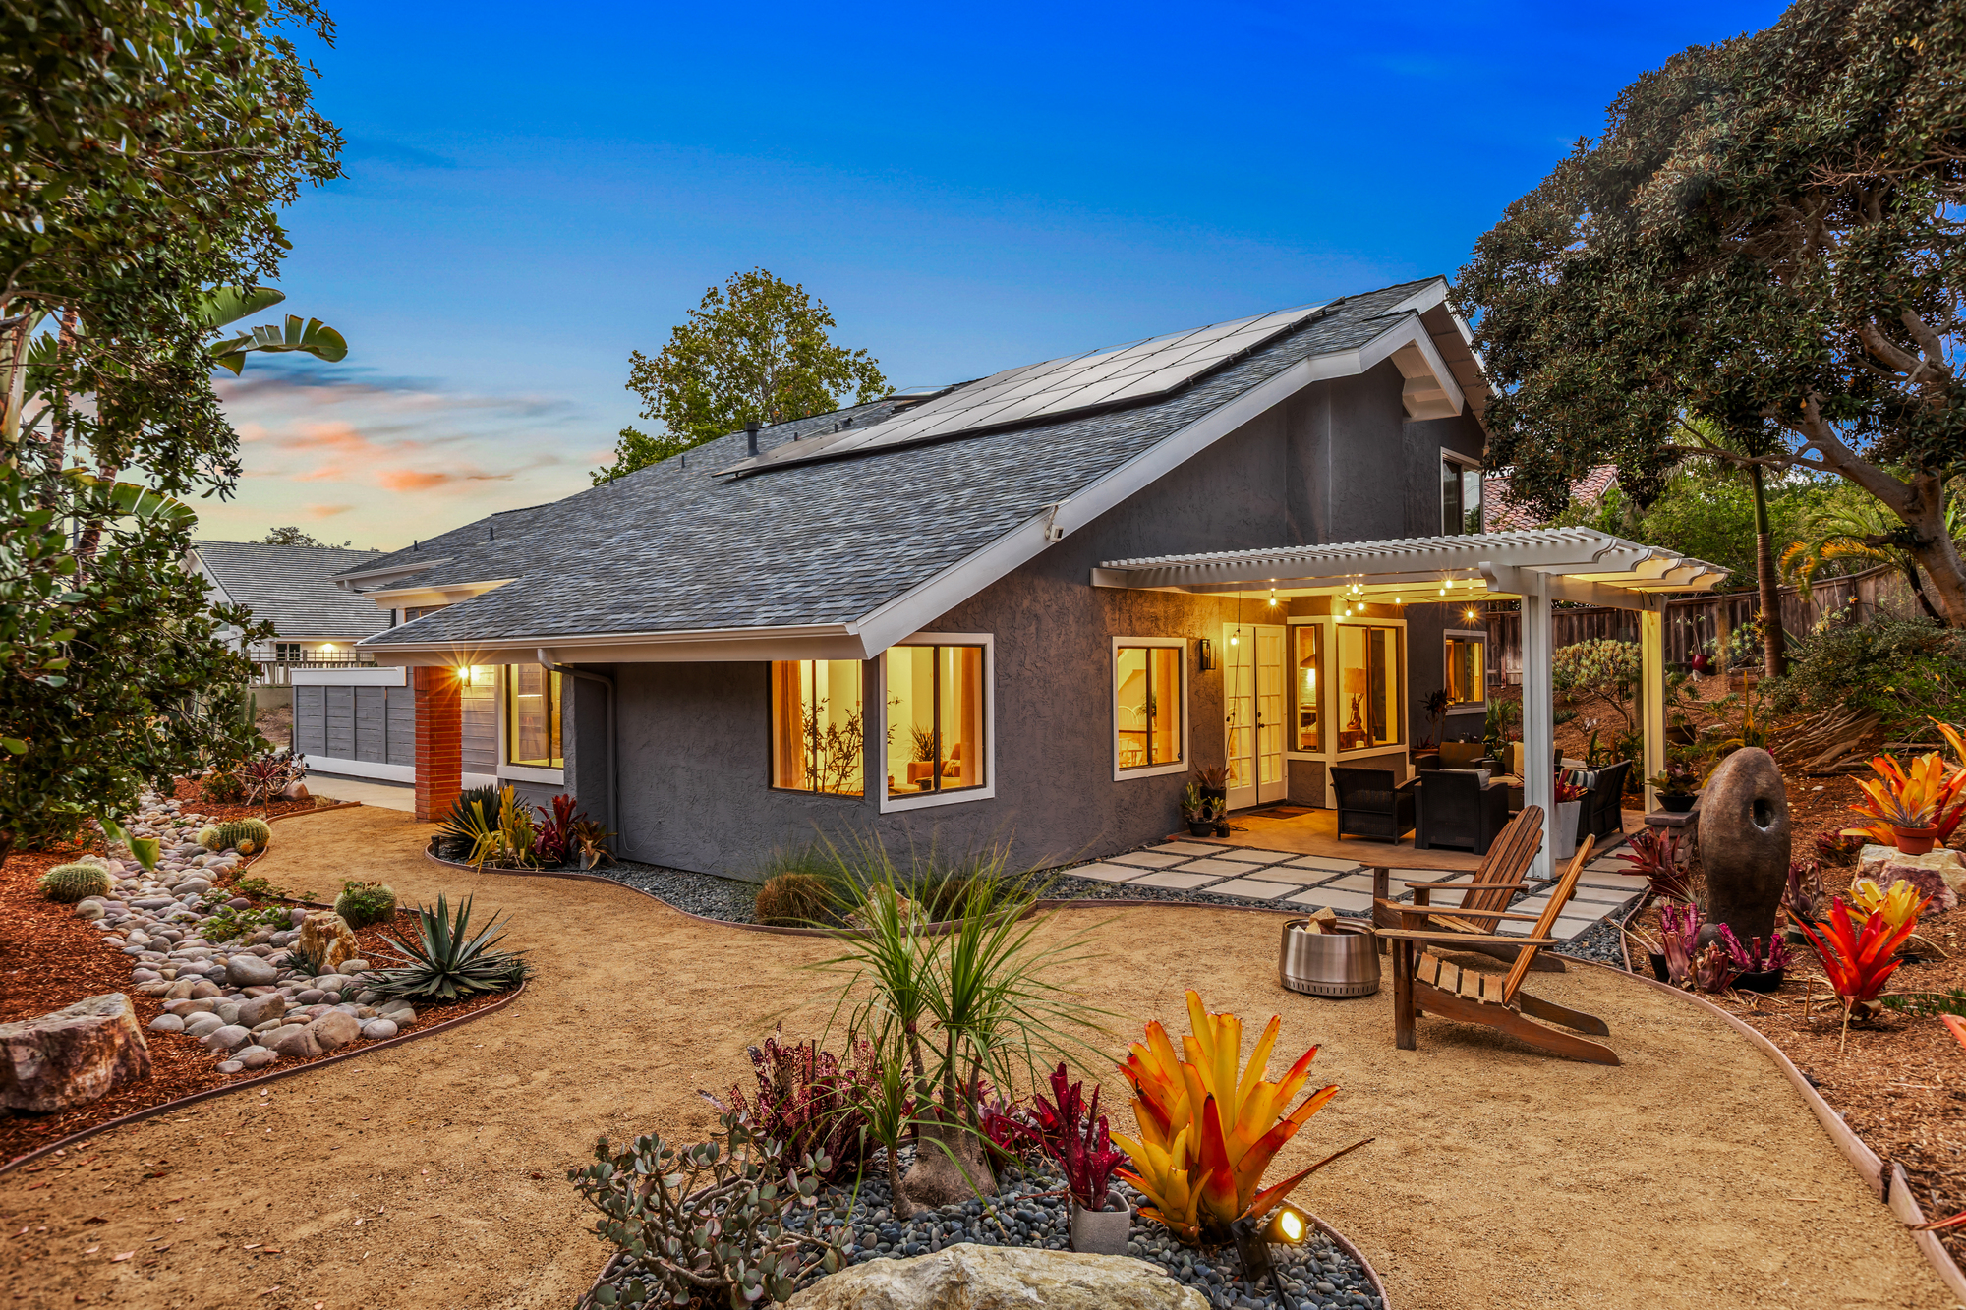
PROPERTY FEATURES

— Owned 20-Panel Solar System  — Large .28-Acre Lot  — No HOA or Mello-Roos  — Vaulted Ceilings  — Entry-Level Primary Suite  — 5 Bedrooms  — New Exterior Paint  — Updated Baseboards  — New Interior Doors | — Drought-Tolerant Landscaping  — Panoramic Ocean Views  — Walkable to Shops, Restaurants & Beach  — New PEX Piping  — EV Junction Box  — Roof Replaced 5 Years Ago  — Newer Furnace & Water Heater  — 3-Car Garage

ADRIENNE MINEIRO | Information deemed reliable but not guaranteed. Buyer to verify all information.

