
17756 Camino Ancho
Mirador | Rancho Bernado
3 Bedrooms | 2 Baths | 1565 SF | $1,050,000

INTERIOR LIVING SPACES
- Soaring vaulted ceilings with exposed wood beams.
- Inviting formal living room with a wood-burning fireplace.
- Dining room highlighted by a beautiful light fixture.
- Spacious kitchen featuring upgraded countertops with tile backsplash, stainless steel appliances, and an oversized sink; sliding doors open to the backyard patio. Samsung refrigerator included.
- Primary suite with sliding doors to the backyard patio and a ceiling fan; upgraded bath offers a soaking tub, separate shower, dual sinks, and a large mirrored walk-in closet.
- Two generously sized secondary bedrooms — one with French doors to the exterior and mirrored wardrobe closets.

EXTERIOR
  - Enjoy panoramic golf course views from your private backyard.
  - Expansive outdoor space featuring a covered patio, open stone-paver patio, outdoor BBQ and low-maintenance artificial turf.
  - Two-car garage with dedicated golf cart parking or additional storage space

ADDITIONAL FEATURES
- Stylish wood-look tile flooring throughout.
- Interior laundry room with Samsung washer and dryer (included and fairly new).
- Newer water heater.
- HVAC system approximately 3 years old.
- Updated dual-pane windows.
Oaks North | 55+ Community
HOA Fees: $370/Month | Oaks North: $595/Year
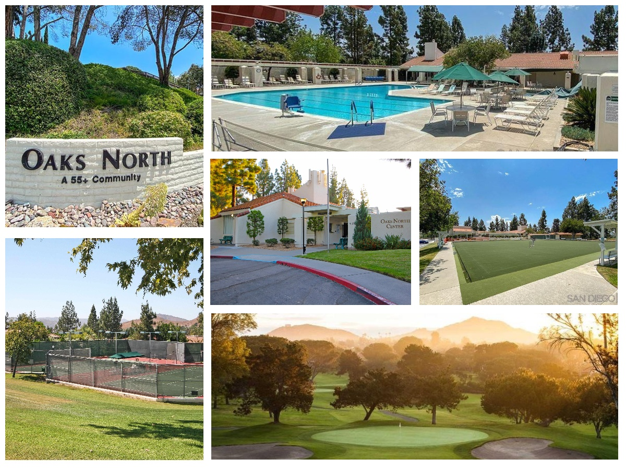
Oaks North is a vibrant 55+ community in San Diego offering resort-style amenities and an active, social lifestyle. The Oaks North Community Center features a fitness room, billiards, meeting and card rooms, plus studios for arts, crafts, ceramics, and woodworking. Residents can enjoy shows in the auditorium or unwind in the library. Outdoor amenities include a sparkling pool and patio, tennis courts, lawn bowling, and scenic walking and biking trails. Golf enthusiasts will love the 27-hole Oaks North Golf Course with driving range, chipping area, and putting green. The nearby historic Rancho Bernardo Winery adds to the charm, offering tastings, events, and leisurely strolls through the vineyard.

