Valley Springs Property Characteristics and Features

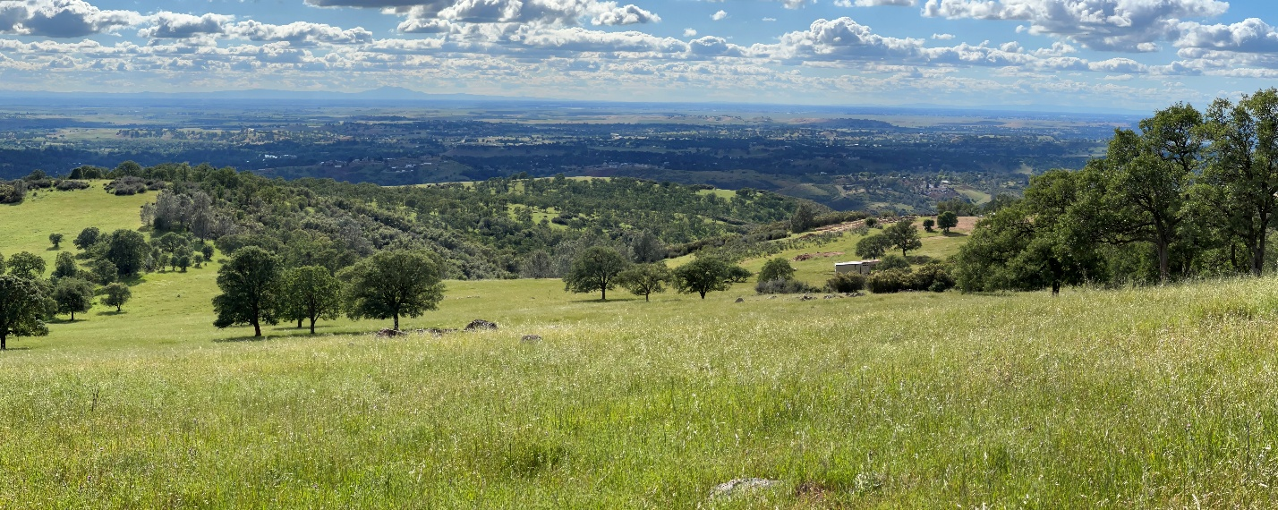
Property Landscape Features:
- Stunning Panoramic Views
- Breathtaking Sunrises, Sunsets, with Beautiful Weather Variations
- Rolling Oak Landscape and Foothill Pines
- Incredible Night Star Gazing
- Springtime Wildflowers and Wildlife Abundant: Bald Eagles, Osprey, Red-tailed Hawk, Wild Turkeys, Fox, Bob-cat, and many others
- Beautiful Horse/Cattle Pasture Land
- 1500 Foot Elevation, Below the Snow Line and Above the Fog Line
Additional Ranch Features:
- Very Private and Secluded 40 Acres [Two 20-acre parcels] Nestled in the Heart of a very large 3000+ acre open land track
- Gated Private Road
- Perfect Country Property for Self-Reliant, Year-round Solar Application
- Broadband Internet Access [Broadband Internet Tower-Adjacent Property/line of sight access/Conifer Wireless or Starlink]
- OES/Cal-Fire Alert System Lookout [Adjacent Property]
- Multiple Building Sites for Future Home Options, all within reasonable distance of well site.
- New building pad development near well site.
- 2026 well placement; 3.0 gpm at 440 ft; well depth at 900 ft with static water level at 700 ft allowing for 600+ gallons that can be pumped at 5 gpm over the first 2 hours.
- Natural geographical land elevations for private gun range
Local Amenities: [All Within 5 to 15 minutes distance]:
- Hogan Lake Reservoir – Fishing, All Water Sports, Hiking, Biking
- 4-6 miles – Full-Service RV Lake Camping, Tent Camping
- 4 Miles – Equestrian Staging Center, Hogan Dam Road, Extensive Lake Front Trails for Horse Back Riding, Hiking, Mountain Biking
- 6 miles – Valley Springs Health & Wellness Center: Primary Care, Internal Medicine, Pediatric Care, Radiology, Sunrise Pharmacy, Behavioral Health, Dentistry, and More Services to Come Soon.
- 10 miles – Center for Integrative Medicine/Functional Medicine
- La Contenta Golf Course – 18 Hole, 72 Par, Professional Golf Pro Shop
- Quality Grocery Market, Ace Hardware, and Many Other Local Businesses
- Entrepreneurial Gourmet Hamburger Bar and Grille
- Thai and Mexican Food Restaurants
- Fast Food – Taco Bell/Burger King
Centrally Located:
- 1.5 Hours Kirkwood, South Lake Tahoe – Great Slopes – Skiing/Boarding
- 1.0 Hour Sacramento/Sacramento Airport
- 2.0 Hour Yosemite National Park
- Gold Country/49’er Highway/Award Winning Wineries
  - 30 Minutes to Murphys – Award Winning Wineries, Great Cuisine, Shopping, Entertainment, Annual Grape Stomp/Calaveras Big Trees [Largest Redwoods in the World]
  - 60 Minutes to Sonora/Jamestown – Award Winning Sierra Repertory Theater, Restaurants
  - 40 Minutes to Green Horn Golf Course, Dining
  - 30 Minutes to Angels Camp, Great Dining, Movie Theater
  - 30 Minutes to Amador County – Award Winning Wineries – Shenandoah Valley, Fine Dining
  - 35 Minutes to Lodi, Award Winning Wineries – Fine Dining
  - 45 Minutes to Famous Columbia state Park and Columbia Junior College – Modesto Junior College Affiliate
  - Farmers Markets and More…

